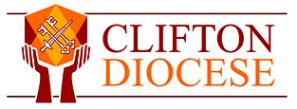

Pastoral Ministry Formation Course
Expression of Interest Form

Name:

Contact Email (Please print)

Parish

Current roles in the parish

Reasons why you might like to do this course:

Is it your intention to seek employment in a pastoral ministry role at the end of the course? (Please circle)

Yes

No

Not Sure

This form does not commit you to participating in the course, but it helps us to know what kind of interest there may be in the course. Please email to sarah.adams@cliftondiocese.com or post to me at
Alexander House, 160 Pennywell Road, Bristol BS5 0TX

