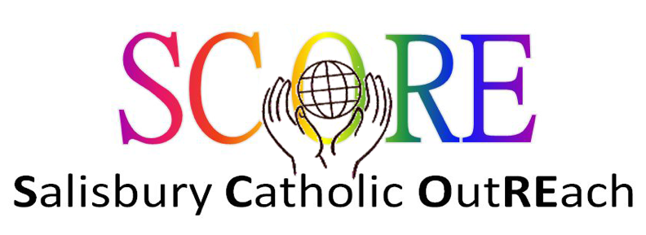

Grant application form

In order for your organisation to be considered for a grant from SCORE this form must be completed in full. Applications can only be considered for overseas projects or projects within the Catholic Deanery of St Edith of Wilton - Salisbury, Amesbury, Tisbury, Warminster.
Please use additional sheets if required.

This form should be submitted at least 2 weeks before the meeting of the SCORE committee. Meeting dates are published on the website: salisburycatholics.org.

Applications should be submitted to:
Chair, SCORE committee
St Osmund’s Parish Office
95 Exeter Street
SALISBURY
SP1 2SF

Or emailed to: office@salisburycatholics.org

Section 1 - details of organisation

1.1 Full legal name

1.2 Address for correspondence

1.2.1 Post code

1.3 Email address

1.4 Telephone number

1.5 Name of contact

1.6 Charity registration number

1.7 Detailed aims and purposes of the organisation.

1.8 Confirmation that the organisation is a Christian based charity.

1.9 Details for payment of grant by bank transfer:

Precise name of account:

For UK payments:

Sort code:

Account number:

For overseas payments:

IBAN or SWIFT code:

1.10 Is this a government funded project or replacing statutory funding?
Yes/No

Section 2 - Details of grant application

2.1 Give the geographical location of the project. Is it located overseas or within St Edith of Wilton Catholic Deanery - Salisbury, Amesbury, Tisbury, Warminster.
2.2 Full details of the purpose for which the grant will be used. (Details should include aims of the project, measures of success, numbers of people who will benefit, anticipated start date, future financing plans to enable the project to continue. Please include any supporting documentation that you feel will assist the SCORE committee in reaching a decision. Please include the total cost of the project.)

2.3 Amount of money requested in this grant application (£).

2.4 Amount of money raised so far and details of additional sources of funding.

2.5 Details of any previous funding from SCORE and an update on how previous donations from SCORE have been spent.

Name: Signature:

Date

SCORE (Salisbury Catholic OutREach) is operated under the authority of Clifton Diocese (A Company Limited by Guarantee registered in England and Wales under number 10462076. Registered charity number: 1170168. Registered office: St Ambrose ,North Road ,Leigh Woods, Bristol BS8 3PW).

9/23

